**MENTOR MEDIA LTD**

**Freight Rates (FR) Portal**

**Function Specifications**

**IMPORTANT**

This information contain herein is the proprietary property of Mentor Media Ltd.

The holder agrees to the following:

1. Not to reproduce or copy it;
2. Not to reveal or publish it in whole or part;and
3. To maintain this document in confidence Framework & Standards

RELEASE HISTORY

|  |  |  |
| --- | --- | --- |
| Release No | Content | Effective Date |
| 1 |  |  |
| 2 |  |  |
|  |  |  |
|  |  |  |
|  |  |  |
|  |  |  |
|  |  |  |
|  |  |  |

|  |  |  |  |
| --- | --- | --- | --- |
| Prepared by | Thanh Trinh | Date | Sign |
| Designation | System Developer |
| Reviewed By |  | Date | Sign |
| Designation |  |
| Approved By |  | Date | Sign |
| Designation |  |
| Document No | Total no of the Pages (Excluding the cover page) : | | Release 1 |

**Authorization Memorandum**

I have carefully assessed the Functional Specifications Document for the Freight Rate Poral

MANAGEMENT CERTIFICATION - Please check the appropriate statement.

______ The document is accepted.

______ The document is accepted pending the changes noted.

______ The document is not accepted.

We fully accept the changes as needed improvements and authorize initiation of work to proceed. Based on our authority and judgment, the continued operation of this system is authorized.

_______________________________ _____________________

NAME DATE

Project Manager

_______________________________ _____________________

NAME DATE

Director

*Add other names and roles as necessary.*

1 INTRODUCE 4

1.1 Purpose 4

1.2 Reference Documents 4

1.3 Abbreviations and Acronyms 4

2 SYSTEM OVERVIEW 6

2.1 Purpose 6

2.2 System Requirement 6

2.3 Pre Setup 7

2.4 Overview of Functional Requirements 7

2.5 Overview of Data Requirements 8

2.6 General Constraints, Assumptions, Dependencies, Guidelines 8

2.7 Design and Implementation Constraints 8

2.8 User Documentation 8

3 REQUIREMENTS 9

3.1 Functional Requirements 9

3.1.1 Login 9

3.1.2 Calculator Price 9

3.1.3 Upload Rate 9

3.2 Performance Requirements 9

3.3 Security 9

3.4 Usability 9

3.5 Other Requirements 9

Appendix A. Analysis Models 10

Appendix B. Issues List 11

# INTRODUCE

The Freight Rate(FR) portal is a web portal which auto calculate freight rates based on the selected source/destination country and rate card. The portal will display recommended service type and prices to user. User will be able to print out the result. The scope of the portal will contain an abstract of the requirements and the feature specifications that are going to meet those requirements, that is in basic terms: the problems and the solutions.

## Purpose

The portal will have some functions which meet those requiments. Every requirement will become to a function in the portal. So that, this document will help us can understand and see things in this portal.

## Reference Documents

This is the list of reference documents which the portal will use:

| Order | Document Name | By |
| --- | --- | --- |
| 1 | Freight Rates Portal (Brainstorming).docx | Yin Yin |
| 2 | Freight Portal BRD 20210625.docx | Yin Yin |
| 3 | DHL Ratecard 01 Jan 21 upload.xlsx | Yin Yin |
| 4 | FedEx Ratecard 01 Jan 21 upload.xlsx | Yin Yin |
|  |  |  |
|  |  |  |
|  |  |  |
|  |  |  |
|  |  |  |
|  |  |  |
|  |  |  |
|  |  |  |
|  |  |  |

## Abbreviations and Acronyms

| Conventions | Meaning | Note |
| --- | --- | --- |
| Rate Card | This is an excel file. It will be generalized standard and allowed to update monthly. Every carrier will have a own Rate card file |  |
| UC | Use case |  |
|  |  |  |
|  |  |  |
|  |  |  |
|  |  |  |
|  |  |  |

# SYSTEM OVERVIEW

## Purpose

The portal is divided into following sections:

* **Login**
* **Calculator**
* **Upload Rate**

## System Requirement

* + 1. **Recommended Hardware and Software Requirement for Server**

|  |  |
| --- | --- |
| Computer/Processor | Intel Core I3 or above |
| OS | Window OS From version 7 or above;  Or Window Server from version 2012 |
| Memory (RAM) | 4 Gb or above |
| Hard disk space | 5Gb |
| Ethernet connection | Speed 1Gbps or above; use WAN network (maybe has internet connection) |
| Software | IIS 7.0 or above;  Web Browser: Chrome, MS Edege, FireFox;  Sql Server 2008 or above;  .Net Framework 4.5 or above; |

* + 1. **Recommended Hardware and Software Requirement for Client/User**

|  |  |
| --- | --- |
| Computer/Processor | Intel Core I3 or above |
| OS | Window/Linux OS |
| Memory (RAM) | 2 Gb or above |
| Hard disk space | 5Gb |
| Internet connection | Speed 100 Mbps or above |
| Software | Web Browser: Chrome, MS Edege, FireFox |

## Pre Setup

* + 1. **Setup for server side**

**Step 1**: The server has install IIS program and hosted the source code of the portal in a branch of IIS Website Tree.

| Pre Setup data into database | |
| --- | --- |
| Table Name | Appendix |
| MS_USER |  |
| MS_EXCEL_WEIGHT_RATE |  |
| REF_PACKAGE_TYPE |  |
| MS_CARRIER_PACKAGE_TYPE |  |
| MS_ SERVICE_TYPE |  |
| **MS_CARRIER** |  |

**Step 2**: Make sure that the database has run the script file which provided by developer for this portal and the connection of server and the SQL Server is working.

**Step 3**: Check the UploadFolder folder has written permission by IIS account. This folder has 2 excel files for DHL and FedEx carrier.

* + 1. **External API Requirments**

Every user can use their 365 Office Email account to login into the portal so that the network connection can communcate with the API which provider by another team via network.

## Overview of Functional Requirements

* + 1. **Login Function**

The login function will help user can use their account(email or their MM email) to login into the portal. The login function will have GUI page which allowed to enter their email (and passowrd).

Only account has existed in the system OR used 2FA layer login method can enter into the portal.

* + 1. **Calculator Function**

The price calculation function allows users to enter information such: origin country, destination country, weight and dimensions like: height, width, size. Based on the enquiry system will do comparison and recommendation.

Comparison will be based on :

Rate Card (SG):

- DHL Standard

- FedEx Standard

- DHL Express

- FedEx Express

- and so on ....

After done comparison and recommendation result will be displayed.

Result would be:

1. DHL Standard $100

2. FedEx Standard $200

3. FedEx Standard $300

**In addition**, the system can show :

- Fuel Surcharge (Monthly)

- Additional Surcharge

**The data flow diagram of this function:**

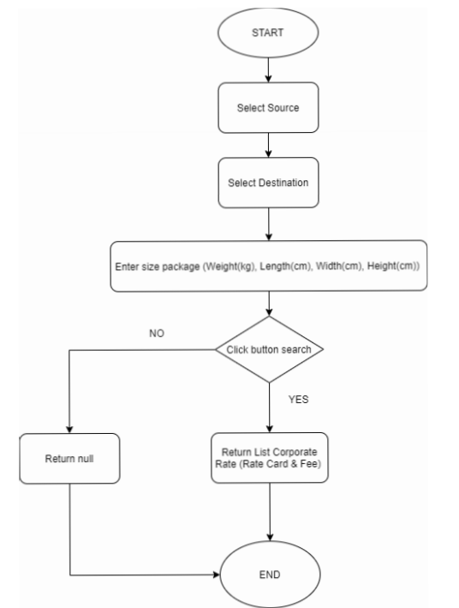

* + 1. **Upload Price Function**

The upload function allows users can update the Rate Card. Rate Card will be generalized standard in excel file format. User can replace the old rate card by new one based on the carrier.

This function will have 2 sub functions: The first will use to upload new excel file (the Rate card) and the second will use to upload new surchage rate file.

**The data flow diagram of this function:**

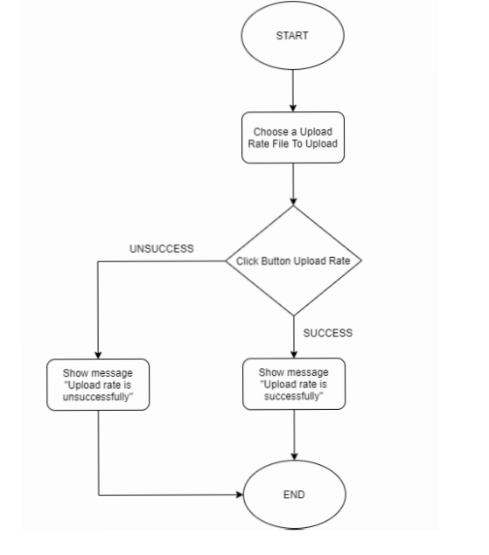

# REQUIREMENTS

## Functional Requirements

### Login

* **User Interface**

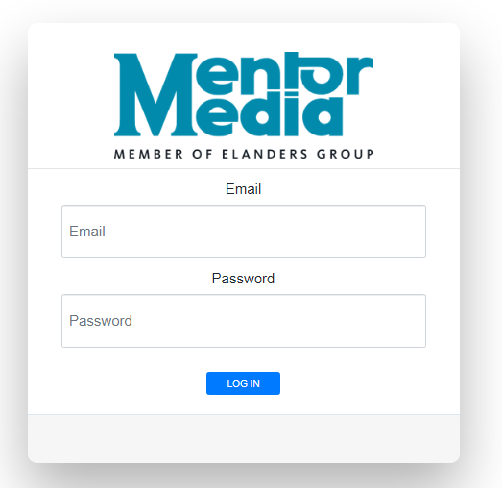

* **Inputs**

| Field Name/Label | Type | Validation | Message | Table Name | Remarks |
| --- | --- | --- | --- | --- | --- |
| Email | Textbox | Mandatory | Not null |  |  |
| Password | Password | Mandatory | Not null |  |  |
| Login | Button |  |  |  |  |

* **Outputs**

| Action | Result |
| --- | --- |
| Login unsuccessfull | Display error the message to user |
| Login successful | Redirect to Calculator Page |

### Calculator

* **User Interface**

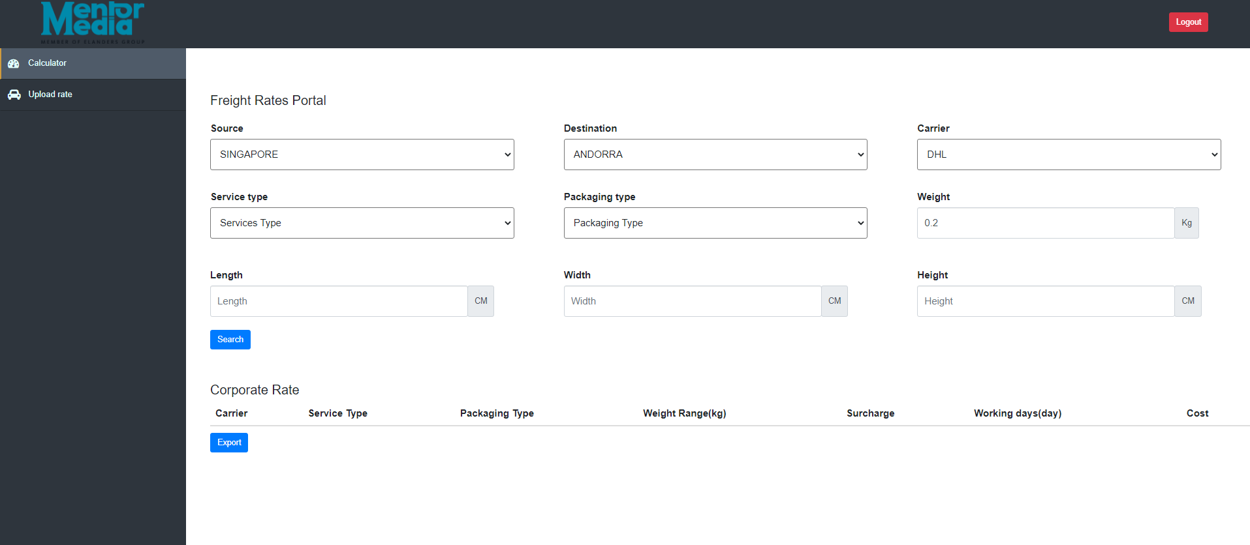

* **Inputs**

| Field Name/Label | Type | Validation | Message | Table Name | Remarks |
| --- | --- | --- | --- | --- | --- |
| Source | Drop down list | Mandatory | Not null |  |  |
| Destination | Drop down list | Mandatory | Not null |  |  |
| Carrier | Drop down list | Mandatory | Not null |  |  |
| Service Type | Drop down list |  |  |  |  |
| Package Type | Drop down list | Mandatory |  |  |  |
| Weight | Textbox | Mandatory | Not null |  |  |
| Length | Textbox |  |  |  |  |
| Width | Textbox |  |  |  |  |
| Height | Number  Textbox | Mandatory |  |  |  |

* **Outputs**

| Action | Result |
| --- | --- |
| Click on the Search button | Show the price table base on the inputs |
|  | Show the error message if not found the price based on inputs |

### Upload Rate

* **User Interface**

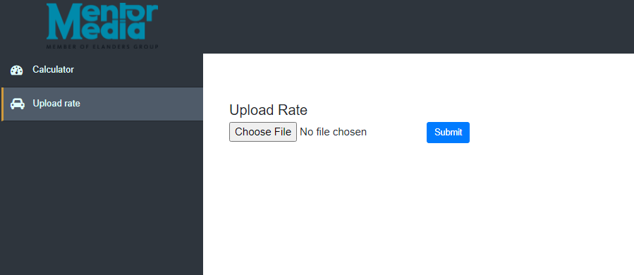

* **Inputs**

| Field Name/Label | Type | Validation | Message | Table Name | Remarks |
| --- | --- | --- | --- | --- | --- |
| Choose File | Textbox | Mandatory | Not null |  |  |
| Submit | Button | Mandatory |  |  |  |

* **Outputs**

| Action | Result |
| --- | --- |
| Click on the Upload button | Show the message based on the inputs |

## Performance Requirements

## Security

## Usability

## Other Requirements

1. Analysis Models

List any attached / referenced documentation such as data flow diagrams, class diagrams, state-transition diagrams, entity-relationship diagrams, etc.

| DOCUMENT NAME | DESCRIPTION | LOCATION |
| --- | --- | --- |
|  |  |  |
|  |  |  |
|  |  |  |
|  |  |  |
|  |  |  |
|  |  |  |
|  |  |  |

1. Issues List

Detail any unresolved issues.

| ISSUE ID | ISSUE DESCRIPTION | STATUS |
| --- | --- | --- |
|  |  |  |
|  |  |  |
|  |  |  |
|  |  |  |
|  |  |  |
|  |  |  |
|  |  |  |